**DANI**

The aim of the assignment is to implement DANI – Dynamic Artificial Non-Intelligence. DANI is what is known nowadays as a conversational agent, and it was inspired by the talking computers of science-fiction such a HAL, the Computer from Star Trek and Eddie from the Hitchhikers Guide to the Galaxy.

DANI starts out with no knowledge of the English language. You type a sentence and DANI responds with a sentence. As you interact with DANI, it learns more and more words and can have a conversation with you. For a complete description see MSX Computing Magazine Feb-March 1987. This is how I think DANI works from my re-implementation.

DANI keeps a list of every word it knows with a link to every word that follows each word in the list along with the count. This can be thought of as a graph of words. Each sentence you enter, DANI parses a list of words. The program then searches its word list for each of the words in the sentence you typed and if a match is found, DANI adds a link to the word following the word you typed. If the link already exists, then DANI updates the count for that link. For example the following words:

“I wandered lonely as a cloud that floats on high ore vales and hills when all at one I saw a crowd a host of golden daffodils”

Generates the following word graph:

I: wandered (1) saw (1)

wandered: lonely (1)

lonely: as (1)

as: a (1)

a: cloud (1) crowd (1) host (1)

cloud: that (1)

that: floats (1)

floats: on (1)

on: high (1)

high: ore (1)

ore: vales (1)

vales: and (1)

and: hills (1)

hills: when (1)

when: all (1)

all: at (1)

at: one (1)

one: I (1)

saw: a (1)

crowd: a (1)

host: of (1)

of: golden (1)

golden: daffodills (1)

daffodills:

The word before the : is the word and the words following are the words that follow the root word with the count.

To generate a sentence, DANI picks a random word from the sentence you just typed and then uses that to start a new sentence. Following the graph from word to word until there it reaches a word with no following word. If there are multiple words following a word, then DANI picks a word at random. DANI should also make use of the word counts, so that words with a higher follow count have a higher probability of being chosen.

Implementing the specification above gets you 50 marks out of 100. For the remaining 50 marks, you have to use your imagination to come up with some improvements to DANI’s algorithm. Some possibilities:

Loading and saving word lists

Pre-populating the word list with a book

Using text-to-speech of speech to text

Creating a DANI avatar using MonoGame

Making DANI support multiple users over a network.

Also the original article has some great suggestions to improve DANI

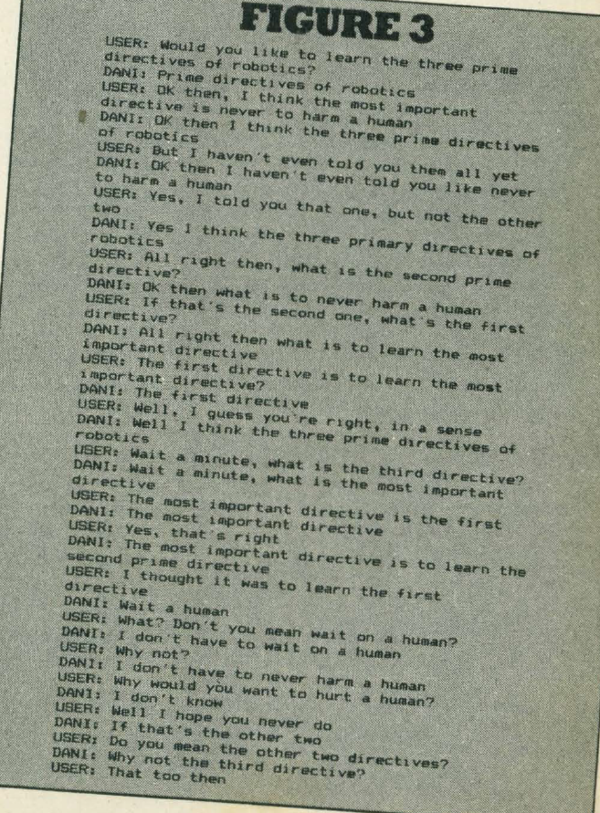

An example of an interaction with DANI:

C: Hello

S: I am DANI

C: I am Bryan. How are you

S: How are you

C: Never better thanks

S: Never better thanks

C: Tell me about yourself

S: better thanks

C: Better than what DANI

S: Bryan. How are you

C: Well actually I am feeling sad

S: am DANI

C: Are you sad too DANI

S: me about yourself

C: I told you I am sad. I dont know what to do about it. WHat do you recommend

S: me about it. WHat do about it. WHat do you sad too DANI

C: I knew you were sad DANI. I can tell

S: recommend

C: I recommend you do something to cheer yourself up

S: me about yourself up

C: Yes

S: recommend you I recommend you do you do something to do about it. WHat do abo

ut it. WHat do something to cheer yourself up

C: Lets have a party

S: than what to cheer yourself up

C: That would cheer us up. We can get drunk. What do you think about that idea

S: party

C: Yay!

S: are you I recommend you were sad too DANI

C: Are you lonely

S: too DANI

C: You are lonely

S: sad. I knew you think about it. WHat do you lonely

C: Well I like to go out and party whan I am lonely

S: think about that idea

C: Where should we go?

S: yourself up

C: To meet some people

S: get drunk. What do you sad too DANI